
2017
Business Plan
Table of Contents
Company Analysis 3
Industry Analysis 11
opportunity Analysis 14
Market analysis 16
Competitive Analysis 25
Marketing Plan 26
Operations Plan 30
Financial Plan 34

Company Analysis

COMPANY
Visionz Group, LLC

FOUNDED
2016

HEADQUARTERS
Belleville, Michigan

MANAGEMENT
Chris Rivers

PRODUCTS & SERVICES
E-Portal
Training Curriculum
Consulting
Youth Focus Groups

CAPITAL ASK
$721,209

FUND USES
Platform Development
Program Development
Initial Marketing
Key Hiring Needs
Operating Working Capital

COMPANY OVERVIEW
Visionz Group, LLC (otherwise referred to as ‘Visionz’ or ‘the Company’) is a revolutionary e-learning platform that allows teenagers and young adults aged 12 to 24 to interactively develop the life skills required for professional and career-focused growth. Visionz is dedicated to providing young people with the critical life skills they need to succeed, and excel in life through cutting-edge tools, a nurturing learning environment, climate, and culture. The Company’s mission is to strengthen the lives of youth through education, empowerment, and support. Over time, Visionz will be an invaluable resource for young people, businesses, and the community at large with the vision to provide at-risk youth the critical life skills they will need to avoid the hardships they otherwise will face.
Since its inception, the Visionz Group has worked toward several goals: to raise urban youth awareness and literacy in technology, to build and market the Visionz brand, to maximize their resources to increase financial opportunities, to heighten self-esteem and to create a safe social environment that empowers them to overcome socioeconomic obstacles.
Many teenagers and young adults are typically unsure of their career trajectory, how their education pertains to the ‘real world’, or how to navigate through professional and educational settings. Founded by father-son duo, Willie Rivers and Chris Rivers in 2016, Visionz was conceived from a passionate desire to aid underprivileged students deal with these difficult scenarios through a captivating, user-friendly experience.

Market Opportunity
Many students across the country graduate high school knowing the history of America, but few have the important life skills required to survive in America. They often leave school without the marketable job skills needed to compete in the marketplace and they struggle to earn a livable wage. What these young people, as well as others in the community, need, are marketable job skills, connections to employers offering long term job opportunities, the opportunity to demonstrate their knowledge, skills and passion for actual work, financial education and internship opportunities to prepare them for professional careers and self-sufficiency.
Visionz Group also stands at the precipice of a new era. Never before has there been a time where people can become wealthy from the creation of a mobile app or the development of gaming software. This climate is changing the entire education system and how it is delivered to students. As classrooms across the country adapt to be increasingly inclusive of technology, the traditional mode of education is rapidly being transformed and supplemented with programs like Visionz.

Program Overview
A significant number of young people nationwide can be categorized as, what in recent years been described in terms such as in crisis, at-risk, marginal and endangered, especially black males. The Visionz e-Portal and app is designed to guide these individuals through the way they learn best – electronically. Using the online platforms, students are given a seamless, engaging learning experience that allows them to absorb life-changing lessons in finance, business etiquette, web development, professional success, and more.
Visionz offers a comprehensive, interactive online platform designed to enhance the lives of at-risk youth by providing them with six critical work place interpersonal and professional skills they will need to be successful in life. These skills specifically include communication, attitude and enthusiasm, teamwork, networking, problem solving and critical thinking.
The highly interactive, experiential learning portal will utilize video and other media to help students make the right choices in everything from choosing what to wear at a job interview to how to present themselves in the community. VIsionz further instructs students on the employability skills needed to secure and retain a job, career exploration, entrepreneurship basics and critical soft skills required to be successful in the work place; "skills to pay the bills". With access to an intensive curriculum with lively and engaging activities, real-world training, and a special app to help them learn, Visionz students will absorb the oft-elusive skills that can make or break an individual.

Target market

End Users
Visionz will specifically target two distinct user types – Youth Learners and Adult Learners aged 12 to 24 – who are offered different functionalities that fit the defined needs of each age range. Both user types will have access to the platform’s Life Skills, Financial Literacy, and Social Media modules; however, Youth Learners will receive access to Workforce Preparation while Adult Learners will have access to Job Skills Training and Professional Job Certification modules.
Figure 1: Visionz User Types

Support Users
Support users include parents, teachers, and mentors of the end users that can serve as a conduit to continue motivating the youth to use the platform and assist them in the overall process as appropriate. The Company will also target community programs, organizations, school districts, non-profit companies, churches, libraries, and workforce development programs as an avenue to reach potential end users.

Customers
Visionz will also sell access to its platform to corporations and non-profits for commercial use. These entities in particular will typically share a similar mission of providing development resources to at-risk, underprivileged youth, and seek supplemental technology to further its program objectives. These prospective customers will be able to license the technology on a per-seat basis for its students within its existing curriculum.

Features & Functionality
The Visionz Group will offer four primary features through its online platform, which will all be launched on a nationwide basis. Each product is detailed below.

E-Portal
The Visionz e-Portal is a web-based, engaging educational tool for young people all over America who have struggled to learn some of the most important life lessons and skills. These young people cannot survive without financial literacy or business acumen, and yet they’re unable to get the help they need; no single operator is presenting the information in a way that appeals to a young audience through formats they understand best. Using the e-Portal and its accompanying app, students are given a vibrant, exciting online learning experience in some of the most important skills areas. Upon entering the e-Portal, users will go through four stages:

Assessment
Each user will undergo an assessment and evaluation that determines the life skills needed for success in their education, employment and everyday life situations.

Information Delivery
During this stage, users will learn the crucial skills needed to succeed. Young people will be engaged and, utilizing an interactive format, students will be encouraged to absorb every part of the Visionz curriculum.

Gamification
In this stage, students will play interactive, engaging games and exercises so that what they’ve learned ‘sticks’. These games will range from brain games, life-decision games, as well as interactive, VR scenario games.

Testing
During this stage, users are tested to evaluate what they learned during the Visionz program through fun and engaging quizzes.

Visionz App
Besides serving as a perfect, in-sync companion with the e-Portal, the app offers a social media-centric experience that serves to enhance the Visionz curriculum. The app will feature a gamification component to fully engage and intrigue users. Further, the app will feature several colorful and engaging characters that lead users through the curriculum, and skills are measured frequently so that each user knows where their strengths and weaknesses lie.
As they continue to use the app, users will grow confident as they see their skills grow. With the app, users learn, even if they feel like they're just playing games.

Training Curriculum

Workforce Preparation
Through the Workforce Preparation segment of the Visionz curriculum, students learn about themselves and their strengths and weaknesses, and are encouraged to target a particular career. They also learn how to acquire the key skills and techniques needed for a successful career and work-life balance. Specifically, this part of the curriculum provides instruction on resume writing, interviewing, career exploration, employability skills, entrepreneurial basics, as well as skills needed to obtain and retain a job. The goal is to provide life support, direct work experience and mentoring relationships that will have a life-long impact on students’ career development.

Life Skills Development
Participants will learn the skills needed to be productive learners and earners in the workplace, while also seeing an increase in their motivation to learn and excel in the critical skills that will lead to them to becoming productive and self-sustaining adults. This part of the course focuses on emphasizing the relationship between what is taught in the classroom as what is required in the workplace.
Soft Skills Taught:

Financial Literacy
This module was designed to help at-risk youth who are typically outside the financial mainstream learn the basic skills of handling their money and finances, including how to create a positive relationship with financial institutions.

Social Media Mastery
Students will learn how to use social media responsibly; to prevent bullying, to protect privacy, to build advocacy, to share news, to promote their brand, to showcase themselves in a positive light and most importantly, to engage in civil discourse.

Visionz Connect
Visionz Connect is designed to connect reputable businesses with the best talent pool in their markets. The Company will help them connect with quality entry-level employees who are highly motivated, possess strong performance skills and best suit their needs.
The job placement service is free for both job seekers and participating employers, neither of which have to be located in same city to use the site. In addition to the Visionz Connect platform, job seekers and employers can use Twitter, Facebook, email and text messages to connect with each other.
Those looking for work can quickly create a profile, enter the type of position they're looking for, how they want to be notified of job openings and how far away from their city they're willing to travel.
There are two basic reasons why job seekers and prospective employers do not connect – the job seeker either does not know where to look for available positions, or they don’t have the skills to succeed. Visionz Connect will solve those problems and connect the job seeker with employers by:
- Maintaining a pool of qualified workers
- Teaching applicants effective job search skills
- Pre-screening qualified applicants
- Posting Employers’ open positions

Business Model
Visionz will utilize four main streams to generate revenue, as detailed below:

Subscription Fees
End users will pay a monthly subscription fee based on two levels of access as seen below:
- First Level Training (Eye Opener) – Designed for Youth 12-14. Access to Life Skills, Financial Literacy, and Social Media Mastery Modules, as well as Live Webinars.
- Second Level Training (Peripheral Vision) Designed for ages 14-24. Includes Access to All Modules in First Level as well as Workforce Preparation Curriculum.

SaaS Licensing
Visionz will license its online technology platform to third-party partners on a per-seat model. These licensees include non-profits and organizations that share a similar mission to the Company and seek to use the e-Portal as a supplemental technology for their existing programs.

Training Curriculum
Visionz will sell its training curriculum to companies, schools, churches and headhunting companies on a national basis. The training curriculum is segmented into four main sections: Workforce Preparation, Life Skills Development, Financial Literacy, and Social Media Mastery.

Consulting Services
Through years of experience in education, the Company’s founders have gained expert knowledge in the field of education and life skills coaching. As such, Visionz’s management team will consult with businesses, non-profit organizations, and colleges and universities to conduct workshops for a flat engagement fee.

Youth Focus Group Participants
Visionz will provide third-party companies with behavioral and consumer analytics services for those seeking to survey the platform’s user base of diverse consumer profiles and demographics. Clients will pay for the services based on the volume of survey respondents received.
Figure 2: Visionz Business Model

Value proposition
Visionz offers a robust value proposition for both users and investors, as detailed below.
Figure 3: Visionz Value Proposition

Key Investment Highlights

All-Encompassing Platform
The Visionz Program is a collective, experiential learning and support program that utilizes the latest technology, instructor-led classroom training, and career exploration activities to teach low-income and at-risk youth the life skills to help them succeed, both in their professional and personal lives. For example, the Visionz Program offers crucial skills such as Workforce Preparation, that includes resume-building workshops as well as interview and networking skills. These skills are absolutely necessary for underprivileged students to master in order to navigate their way in both education and professional circumstances.

Driving Professional Growth
By showing students their personal opportunity today, Visionz will help unlock the possibilities of tomorrow through creating a simple pathway they can follow in order to achieve success. Specifically, Visionz will focus on youth that are most in need of help in understanding how to focus their aspirations and how to create a roadmap to achieve success. The Visionz platform is a way for youth to integrate their day-to-day education into the vision of their future growth and potential.

Interactive Curriculum
Developed by several business professionals and entrepreneurs who have already held successful training courses throughout the country, the Visionz app and curriculum were created for engagement, using relevant, real-life scenarios and role-playing to reach even the most closed-off, disengaged students. Between the curriculum and the app, Visionz students will learn how to present themselves at a job interview, manage a budget, navigate a business environment, and more.

Exponential Market Reach
The Company’s goal is to dramatically scale its operations to become more connected with other successful programs in the communities that it serves by creating and licensing its SaaS to serve an exponentially greater number of students. In 5 years, the Company envisions providing access to 100,000 young people across the country and making Visionz the leading platform for life skills education. With a combination of word of mouth, corporate relationships and a prominent cultural figure to promote and champion this learning mechanism, the Company will position itself for acquisition from a bigger entity that can take and enhance what it has established.

Minds Behind the Project
The Visionz Project is the brainchild of entrepreneurs Chris Rivers, as well as his father Willie Rivers, retired Vice-President of a major financial services company. Visionz instruction is given in a safe, non-judgmental environment, ensuring that each student is free not only to learn new skills, but to flex what they've learned throughout the course.
According to Willie Rivers, children in the past learned everything from socially acceptable behavior to financial skills by trailing their parents and observing their interactions in the community. However, the financial world today is much more complex than that of previous generations, thus today's knowledge-starved students are merely told to learn on their own using the Internet; a method that is hardly engaging, or very effective.

Industry Analysis

job training & career counseling Industry Overview
The Visionz Group will be disrupting several industries. As such, it is important for Visionz to analyze relevant parallel industries associated with its market potential. One such industry is the Job Training & Career Counseling Industry, which includes operators that provide vocational or job counseling to individuals, including services to those who have a job market disadvantage due to a lack of education, job skills, or experience.

Industry Performance
The $13.4 billion industry is composed of operators that provide job training and counseling, and are typically nonprofit or government entities. Through government funding and private contributions, these operators help unemployed individuals to further develop their skills in order to qualify for specific employment opportunities.
The Job Training and Career Counseling industry previously benefited significantly from stimulus funding during the years after the recession, but now as the economy picks up and government budgets decline, demand is slowing down for traditional industry services. This represents a great opportunity for VISIONZ, as visionz offers a revolutionary alternative for young adults to traditional career counseling operators that exist today.
Figure 4: Job Training & Career Counseling Industry– Key Industry Metrics (IBISWorld)

While this industry has historically experienced steady revenue growth, the economic bubble created volatility. As unemployment skyrocketed, the government refocused its efforts on getting people back to work, funding more job training and career counseling programs during the height of the recession. However, as more people returned to work and the unemployment rate declined, a reduction in demand, accompanied by difficult budgetary conditions at state and local levels, caused government funding to contract. Consequently, industry revenue is expected to fall at an annualized 1.1% during the period.
During the five years to 2021, revenue is forecast to grow slowly, rising at an average annual rate of 0.3% to $13.6 billion as government budgets improve. However, soft demand will limit growth as the economy continues to grow, unemployment falls and the number of job seekers decreases.

Industry outlook
Over the next five years, unemployment is expected to continue declining as consumer sentiment and business profit improve after the recession. Businesses are anticipated to hire workers when corporate profit increases, so people will not be as likely to seek professional help during their job search.
Figure 5: Job Training & Career Counseling Industry Historical and Future Revenue 2011-2021 (IBISWorld)

However, there will still be a need for job trainers and career counselors as Americans look to the industry for help in advancing their careers. Visionz will capitalize on this demand, offering an innovative, modern solution to the problems of finding and qualifying for a job in the 21st century. As a result of these trends, industry revenue is forecast to rise over the next five years, albeit slowly, at an average annual rate of 0.3% to reach $13.6 billion in 2021.
Revenue is projected to rise 0.7% in 2017 as government funding for social services increases substantially. However, as revenue growth remains meager, industry companies are expected to increase efficiency and cut costs. For example, operators will likely take advantage of inexpensive marketing opportunities through social media, thereby reducing advertising expenditure. As a result, profit is projected to increase moderately during the outlook period.

Demand determinants
The Job Training and Career Counseling industry is affected by the unemployment rate, the age of the workforce and the social/political climate. Since the majority of this industry is made up of non-profit operators, (estimated at 82.4% of industry revenue in 2016), government funding is an important source of revenue. Therefore, the increase in demand for services in this industry may not always result in an increase in revenue.

Unemployment Rate
One of the most important factors that affect industry demand is the unemployment rate. Any increase in unemployment will result in an increase in demand for this industry. If more people are being laid off from work, then more people will turn to career counselors and job trainers to seek advice.
Statista predicts that US unemployment rates will remain roughly the same until 2019, when unemployment rates will increase sharply. Looking ahead, if unemployment rates are consistently predicted to be high, visionz’s target market will be that much greater, as there will be more of a demand on services that aid employment qualification.
Figure 6: US Unemployment Rate 2015-2020 (Statista)

Youth Population
Demand for career counseling usually increases if the youth population rises. The post-recessionary climate has proven that younger people must compete with older people to find jobs. As a result, the youth increasingly require outside career counselors to help them to identify and qualify for their career goals.
According to data from census.gov, there will be roughly 75 million individuals under the age of 18 by 2020. Roughly equivalent to 22.3% of the total population, the number of individuals below the age of 18 is a strong indicator of how much demand there will be for the Company’s services. Connecting employers with potential employees will be a much sought-after service for individuals in the future.
Figure 7: US Population Growth of Those Under 18 Years of Age in Millions (Statista)

opportunity Analysis

Market Problems

An Under-performing Education System
The challenge of ensuring educational equity is formidable. The US’ international competitors are improving faster educationally, and many are having greater success in closing achievement gaps—which remain stubbornly wide in the United States. Today, the US ranks 24th in the world in literacy, 17th in educational performance, and 54th in total educational expenditure. The education system in the US has never been more under threat, and a revision to the system is sorely needed.
Structural barriers, including inequitable funding systems, impede our progress. While one might expect schools in low-income communities to receive extra resources, the reverse is often true; a Department of Education study found that 45% of high-poverty schools received less state and local funding than was typical for other schools in their district.
Visionz is fully aware that traditionally underserved students, including minorities and low-income students, attend and complete college at far lower rates than their peers. These students are suspended, expelled, and drop out at higher rates, and are less likely to have access to strong teachers and challenging curricula. As just one striking example, a recent study of the Advanced Placement exam in computer science found that in 11 states, no African-American students took the exam; in eight states, no Hispanic students participated.
However, had these students the resources, mentorship, and guidance to give them opportunities to succeed as well show them the opportunities that they could be afforded in the future, these truths may not be truths. This is where Visionz will have full effect – offering youth who are just beginning to think about careers with the proper guidance and resources required to succeed.

Lack of Mentorship & Youth Understanding
Results from a multi-year ‘College and Career Readiness’ survey of 165,000 high school students conducted by YouthTruth found that only 45% of students feel positive about their college and career readiness. The same study found that only 56% believe that their school has helped them understand the steps they will need to take in order to apply to college.
Today more than ever, there is a distinct lack of youth understanding in 2017. Students, particularly those from low-income families struggle to see the connection between what they are learning in school, and how it applies to the ‘real world’. This is a direct result of the inefficiencies of the education system, coupled with a lack of student social welfare programs.
Students are increasingly unsure and confused about which path to pursue after high school, as shown by the statistic from the same YouthTruth study that only 46% of those surveyed said that schools had helped them figure out which careers match their interests and abilities.
Because American students are increasingly confused about which path to take, how their education relates to the next step in life as well as how to set and achieve their goals, there is a dire need for Visionz’s services in the country. Visionz can show students how to handle daily activities to achieve success, with the added incentive of accumulating Visionz points on the way, and provide them with a user-friendly, technologically-relevant interface to improve their educational experience.

High Unemployment Rates Among Young Adults
With the unemployment rate for young adults without a high school diploma at 13.1 percent, high school credentials are becoming an increasingly crucial requirement in the emerging U.S. economy. However, the gap between employment opportunity and eligibility expands with every disengaged youth as 7,000 students drop out of high school every day.
This problem is compounded by the fact that a traditional high school curriculum alone cannot provide the full set of skills required by employers in today’s demanding job market. For youth to be successful, traditional education needs to be supplemented with further education and transferable work experience. Consequently, these factors contribute to why youth aged 16-19 face the highest rate of unemployment of all age groups and why they eventually fail to become productive adults.
Visionz is the solution to this problem. Combining a technologically-relevant format with key life skills courses, Visionz will bridge the gap between employer and employee, while supplementing the traditional high school curriculum to provide students with real-world skills they will need for employment.

Lack of Educational Supplementation
There are three key reasons why youth need to be supported to ensure their successful transition from youth to adulthood with family-sustaining employment is necessary.
First, the lack of education and job training significantly lower an individual’s lifetime earnings. In fact, the lifetime earnings gap between those without a high school degree and those with high school credentials is $400,000. Shrinking employment opportunities for youth aged 16-19 only compound this problem further. In the 10 years between 2000 and 2010, the percentage of youth aged 16-19 employed in the workforce fell by more than half from 45.2 to 28.6 percent.
Second, this situation will be exacerbated as the current population grows into adults. According to a Harvard Graduate School of Education study, in the 10-year period from 2008 to 2018 the U.S. economy will create 47 million jobs. However, only 36 percent of these jobs will be available to individuals with a high-school diploma or less compared to 72 percent in 1973.
Third, failure to complete high school and transition successfully to adulthood has direct costs to government and society. A single disengaged youth places an estimated burden of $704,020 on society over his or her entire lifetime. Disengaged youth are also more likely to be living in poverty, receiving public assistance, in prison, on death row, unhealthy, divorced, single parents, and, ultimately, high school drop outs with children who drop out from high school themselves.

Market analysis

visionz market overview
Through its varied product and service offering, Visionz will target several different demographics and markets. However, the core target market for Visionz is the e-Portal users, which will be segmented into Youth Learners (12-18) and Adult Learners (18-24).
Figure 8: Visionz Market Breakdown

YOUTH LEARNERS
The Youth Learners target market consists of students aged 12-18. In order to fully gauge the size of this market, Visionz will analyze the areas with the largest population of 12-18 year olds. Youth Learners will receive access to the Life Skills, Financial Literacy and Social Media modules.
Throughout the country, there are an estimated 39 million Americans aged between 12 and 18. A new report from the National Center for Poverty found that 44% of children, around 15 million, in the US live in low-income households. Low income is considered as 200% of the federal poverty line, or a household income of $48,500 for a family of 4.
Of the low-income children, 22%, or just over 3 million children, live in poor households, defined as 100% of the poverty level, or an annual income of $24,250 for a family of 4. This represents a staggering number that reflects not only the dire state children face in the US, but also reflects the potential target market for Visionz.

HIGH SCHOOL DROP OUT RATES
Every year, over 1.2 million students drop out of high school in the US. This equates to a student dropping out every 26 seconds, or roughly 7,000 students each day. About 25% of high school freshmen fail to graduate from high school on time, and the US ranks 22nd out of 27 developed countries in its high school graduation rate. It is clearer now more than ever, we are failing our students.
Despite this, we continue to chastise students for a lack of ‘employable’ skills, claiming that they are ill-prepared for the ‘real world’ of employment. In reality, it is our classrooms, syllabi and rules that are failing to prepare our students, not the other way around. We live in a world in which we have the repository of total human information at our fingertips, yet we continue to ban and confiscate Internet-connected devices in classrooms. Rather than equip our students with knowledge of how to use the Internet in a meaningful, constructive manner, most national syllabi choose to ignore the Internet and its uses.
It is time that we, as a society, embraced the Information Revolution, updated our nation’s education system to reflect today’s society, and, ultimately, better prepare our children to become productive members of the workforce; and Visionz is the best approach to do this.
Figure 9: Adjusted Cohort Graduation Rate (ACGR) for public high school students by state
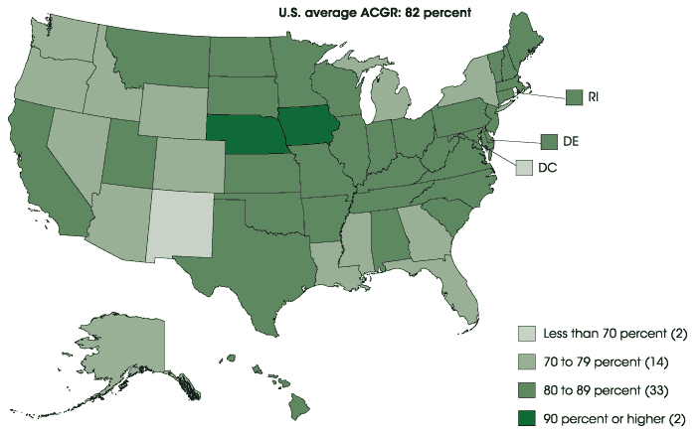

Visionz was designed to bridge the gap between an outmoded education system and a highly-technological workforce. By creating a forum that students are familiar with, the will encourage students and employers to engage with one another, allow parents to play an active role in their child’s success, all while embracing the same technology shunned by today’s education.
On average, a high school dropout will earn $200,000 less than a high-school graduate over a lifetime, and around $1 million less than a college graduate. Moreover, high school dropouts commit about 75% of domestic crimes in the US. From these statistics, it is clear that if we can do something to intervene in a student’s life while they’re in high-school, their chances of leading a successful, happy and productive life are that much higher.

SUPPORT USERS
The Youth Learners will have support users encouraging them to use the Visionz portal and curriculum. As such, it will be necessary for visionz to target these users to increase the user base for visionz. These support users will mainly consist of parents, teachers and mentors. A full demographic breakdown can be found below.

Parents
Parents play a crucial role in the development and success of their children. A recent meta-analysis conducted by Child Trends showed that students with parents who are involved in their school tend to have fewer behavioral problems and better academic performance.
According to a study held by the National Center for Education, students whose parents were actively involved in their child’s education, (by attending parent meetings, checking on their homework and maintaining open communication with teachers) experienced an average of 54% higher grades in core subjects – Math, English and Science. In light of these results, it is clear why parents would want to get involved with their child’s education.
According to a survey conducted by Public Agenda, 65% of parents said they wished they could be doing more when it comes to involvement in their child’s education, with only 34% claiming that they were satisfied with their current level of involvement.
However, in that same survey it was found that although they want to get involved, parents don’t know much about their child’s school system. Only 22% of surveyed parents could name a basic milestone that their child should have learned in school over the previous year, such as multiplication tables, or reaching a certain reading level.
This ignorance is largely due to a lack of understanding of the school administration. In a separate study conducted by Public Agenda, 27% of parents said they knew nothing at all about the qualifications of their child’s principal, while 28% say they know nothing at all about what the superintendent is responsible for.
It is clear that parental involvement in their child’s education produces better results across the board. It is also clear that parents wish they could get more involved, but are confused about the system and the process, and don’t know where to begin.

TEACHERS/MENTORS
It is increasingly uncommon to find classrooms in which phones and laptops are banned. According to a survey from digital education company TES Global, 84% of teachers at the K-12 level are using some form of technology in their lesson plans. In 2015, 35% of teachers said that Internet connectivity was a hindrance to successful teaching, but only 16% felt that way this year. This rapid change of attitude suggests that mobile and web-based activities are proving increasingly important for student development.
As teachers (and students) grow bored of chalk-dusted classrooms, technology-based educational aids are proving increasingly successful at keeping students engaged and interested in school. In a survey conducted by software developer Wondershare, it was found that 82% of teachers wanted tablets or laptops in their classrooms for their students.
TES Global Teachers conducted a study in which they asked teachers which technology they would most like to use in classrooms. The results, below, are overwhelmingly leaning toward game-based learning (24.7%). Visionz is modeled off a game-play format, with users collecting points for academic and extra-curricular achievements, suggesting that it will be the perfect technology to supplement teachers’ needs.
Figure 10: TES Global Teachers Study

This trend is spreading worldwide, with ‘AltSchools’ in San Francisco, Manhattan and Chicago offering highly tailored education that uses technology to target students’ needs. At these small schools, each child is issued with a tablet on which to do their homework and upload it for the teacher to grade. Each student’s grades get added to their online ‘Learning Progression’ – a software developed by the school that tracks, records and analyzes a student’s progress. Although these schools are small and sparsely-distributed, this kind of education is the future. As technology becomes increasingly embedded in our society, our education system should also be quick to adopt to global changes.

ADULT LEARNERS
The Adult Learners user segment is aged between 18-24. Currently, there are an estimated 33 million Americans aged between 18-24 in the US, representing Visionz’s total potential market size. Visionz will target these users and offer them specific Job Skills Training as well as the Workforce Preparation, Life Skills, Social Media Mastery and Financial Literacy segments.
According to Reuters, low-income and minority students were hit particularly hard following the recession. Young people from low-income backgrounds are being ignored and isolated from the workforce, largely due to the complex, multi-faceted economic system that can seem daunting to some. For example, in 2016, the unemployment rate among 18-24 year olds was a shocking 28%.
Young adults are forced to compete with more experienced and more educated workers, and, with employers tightening their budgets, are lacking the interpersonal skills and work experience as a result of not being employed. This leads to paradoxical vicious cycle in which employers refuse to hire workers ‘with no experience’ and first-time workers can’t get experience.
Not having prior work experience can damage an individual’s future earning potential significantly. A 2001 Employment Policies report found that a six-month unemployment period ‘can reduce future wages by 2.3%’. Young adults with prolonged periods of unemployment are particularly susceptible to unemployment as they grow older. Something must be done to break this’ vicious circle’, and Visionz will be the ultimate vector to facilitate this revolution.
Visionz will help specifically low-income, unemployed young adults prepare for employment through its easy-to-use digital platform. The biggest challenge that causes the divide between high-income and low-income young adults is the availability of resources.

HIGH SCHOOL SENIORS AND GRADUATES
Visionz was specifically designed to help both high school seniors and recent graduates to understand their best career move, and to easily put them in contact with potential employers. As such, Visionz wants to give our young adults an opportunity to succeed, to fully thrive in the workplace and in school.
“In 2016, the unemployment rate for young high school graduates was 17.9%”

In 2016, the unemployment rate for young high school graduates was 17.9%. According to the Economic Policy Institute, this figure was 15.9% in 2007. The American job market no longer has time for high school seniors. In 1990, 32% of high school students held jobs while in school; today, that figure is lower than 16%. High School students, particularly seniors, are being pushed out of the job market, with sectors that have historically employed this demographic – fast food, movie theaters and mall retailers – increasingly turning to older employees to fill their workforce.
This trend is dangerous for the American economy, as instilling a work ethic from an early age is key in securing a strong labor force in the future. With whole industries completely shutting out students from getting jobs, how can the next generation be prepared to succeed in the labor force?
McDonalds and other fast food chains used to be the leading employer of high school students. However, local McDonalds managers are no longer forced to accept students that can work after class. Instead, as a result of the recent financial crisis, these managers have the option of employing out-of-work college graduates, or older Americans forced back into the workforce due to financial necessity.
This trend is particularly worrying when analyzing the desire among high school students to enter the workforce. In a study conducted by YouthTruth, just 46% of students said that their schools had prepared them to find a career that matched their interests and abilities. Further, just 36% of students said that they used counseling services to help them figure out future career possibilities. Visionz can position itself as the solution to these failing counseling services, offering students a real perspective and pathway to develop their own professional career.

COLLEGE STUDENTS
College is often hailed as being the ‘great equalizer’ between social classes. It is a myth purported that low-income students attending college will achieve the same level of success, or at least have the same opportunities, as college students from middle or upper-class backgrounds. For example, middle to high-income students are reported to earn 162% more than students with a high school degree, whereas this statistic for low-income students is considerably less – an increase of 91% in lifelong career earnings. Whilst this is a step in the right direction, our college system is far from creating an environment of equality.
This trend is largely caused by one main factor. The first is that low-income college graduates do not have the resources, or perhaps the social connections, to acquire a job after graduation. As such, low-income college graduates, while attending the same university, will not have access to a plethora of resources and employers that a high-income college graduate would have access to.
Visionz would like to even out this playing field by democratizing the American economy. Visionz will shorten the divide between high-income graduates and low-income graduates. Low-income graduates would then stand a slightly greater chance in the workplace, largely due to their options being readily available on one universal platform.

Geographical Market overview

Filters to Consider
When deciding where to launch its operations, Visionz will look for several different indicators to determine the market opportunity of each area. Below are the factors for Visionz to consider before choosing where to focus its resources:

Population Size Under 24
Before entering in any new market, Visionz will analyze the population size under 24 in the area. This is a crucial indicator of whether the Company will be successful in the region, because ultimately the primary market is students within this age group that are confused about their career and life goals. The number of individuals under the age of 24 will denote how big the primary market is going to be.
For example, in the state of Michigan, there an estimated 1.7 million individuals under the age of 24, according to the US Census. This equates to roughly 18% of the population, suggesting a sizeable target market for Visionz.

Unemployment rate
Unemployment rate is an indicator of how severely the population needs the services to facilitate communication with a potential employer/recruiter. Areas with higher unemployment rates would serve as better target markets than areas with lower unemployment rates, as more consumers would need to use Visionz’s services to find employment.
As of April 2015, Michigan’s unemployment rate was 5.4%, slightly higher than the national average of 4.9%. Again, this would suggest that Michigan is a suitable place for Visionz to focus its efforts.
Figure 11: Unemployment Rates by State, December 2016
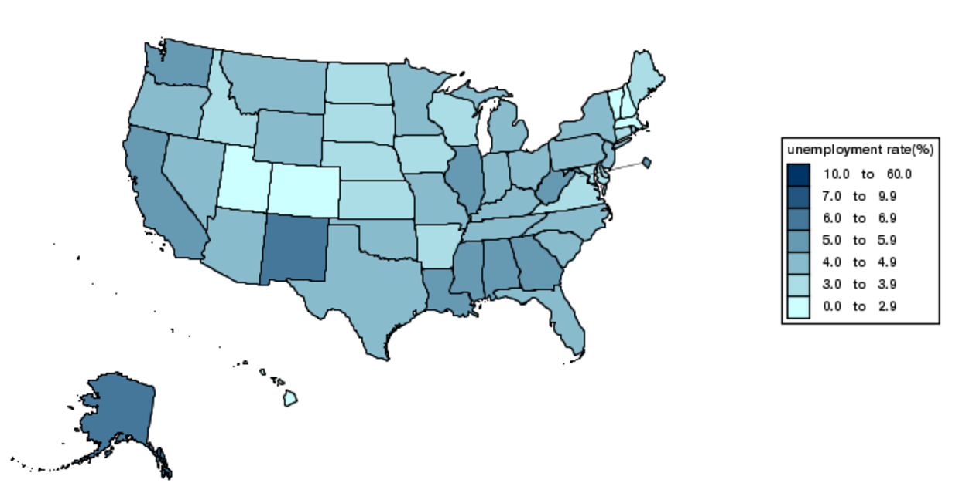

College Graduates
The unemployment rate for Black college graduates is typically twice as high as white college graduates, the Economic Policy Institute, a Washington, D.C.-based think tank reported in May, 2016. The unemployment rate for young Black graduates is still worse today than it ever was for whites in the aftermath of Great Recession.
Young Black college graduates — 24 to 29 years old — currently have an unemployment rate of 9.4 percent, higher than the peak unemployment rate for young white college graduates during the recovery, which was 9.0 percent. The unemployment rate for white college graduates is now 4.7 percent.
Eighty-five percent of success in getting a job, keeping a job, and moving up in an organization is due to people or “soft” skills; 15 percent is due to technical skills, or the knowledge required for a job. According to HR professionals and corporate executives, these people or “soft” skills and emotional intelligence skills are lacking in today’s college graduates. The good news, however, is that these skills are much easier to learn than the technical skills it took years to learn.
Visionz intends to be the missing link between the student’s education and success in the professional business world. Their soft skills training program will equip college students with the essential leadership and social skills required to be polished professionals in the business world.
Topics include: How to distinguish yourself from the competition with your presence meeting and greeting basics; interview and business meeting protocol; how to build rapport for successful business relationships; professional business office decorum; electronic business arena communications; dressing appropriately for your profession; and much more.
Visionz soft skills training will be delivered through consulting arrangements with colleges and universities.

High School Graduation rate
High school graduation rates are reliable indicators of several socio-economic issues in the area, but none more so than how connected students feel with their educational process. As Visionz targets students who face a below-average school system, the Company would do best to focus its efforts on areas where the high school graduation rate is lower than the national average. Additionally, high school graduation rates for particularly low-income students should be observed when possible.
In the state of Michigan, 79.65% of all public school students graduated from high school in the 2015-6 academic year. This is slightly lower than the national average of 83.2%, suggesting that Michigan would be a good place for the Company to focus.
Additionally, Michigan has a disproportionate number of lower-income students graduating from high schools. For example, in the 2012-3 academic year, 87% of middle-class and affluent students graduated on time compared to 64% from low-income households.
Figure 12: High School Graduation Rate by State, December 2016
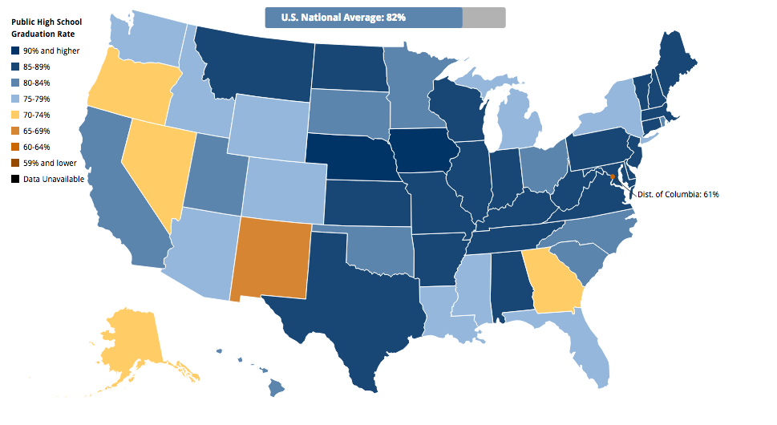

Household income
Average household income is a strong determinant of the socio-economic class of a particular region, and therefore a good indicator of whether Visionz can find a valuable market. Visionz was designed for typically low-income, disadvantaged communities, and household income is a strong determinant in assessing the opportunities a region offers its children and teenagers.
The median household income in the state of Michigan is $49,576 per annum. This is significantly lower than the national median income of $55,775, and therefore a suitable target for the Company’s products and services.
Figure 13: Median Household Income by State
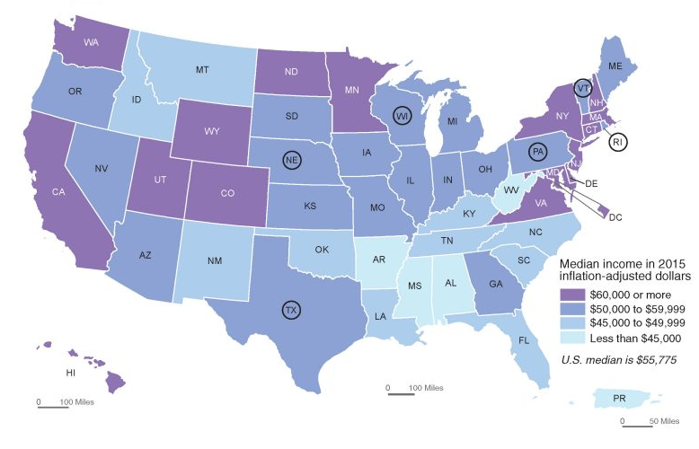
Further, Michigan has a notoriously large student population living in low-income households. Today, almost half of Michigan students live in low-income households, a number that has increased significantly over recent years. For example, in the 2013-14 academic year, 48.5% of Michigan schoolchildren qualified for the subsidized lunch program compared to 36% in 2006-07 academic year.

School Rankings
Finally, national school rankings should be used to determine the status of a region before Visionz chooses to focus its business there. Typically, the Company wants to focus on underachieving schools in lower socio-economic areas. Therefore, the lower the region is placed in national school rankings, the more opportunity there will be.
Figure 14: Spending per Student, by School District

Competitive Analysis
Below is an analysis of the competitive landscape Visionz will be entering. Although there are no direct competitors offering the same product in the market, relevant substitutes include life skills and educational courses tailored toward young adults, such as The Khan Academy. These interfaces often have educational content but are mainly focused on the core high school curriculum subjects. Visionz will revolutionize the industry by offering key life-skills courses, offering a product like no other on the market. Utilizing a platform that is both engaging and interactive, Visionz will offer young adults with a greater vision and purpose to help them understand their career and life potential.
Figure 15: Visionz' Competition Analysis
 | Khan Academy | Study.com | Arise Life Skills
Headquarter | Palo Alto, CA | Mountain View, CA | Jupiter, Florida
Date Founded | 2006 | 2002 | 2007
Company Overview | The Khan Academy offers educational videos accessible to students, teachers, home-schoolers, principals and adults returning to the classroom. The Khan Academy’s materials and resources are completely free of charge. | Study.com is the simplest, most efficient way to learn online. Over 25 million students a month use our online courses and study tools to master any subject. Study.com helps students in kindergarten through college excel academically and professionals can gain the skills they need in the workplace. The animated videos bring concepts to life and provide an easy, low-cost way to improve grades, earn college credit, and close skill gaps | Life Skills are not hereditary; they must be taught. With this mindset, Arise Life Skills dedicates itself to building social and emotional fitness in youth and young adults. The company targets at-risk youth specifically, to help them achieve their highest potential in life as law-abiding citizens.
Services | Free Online Courses, Lessons and Practices | Middle School, High School, College Level Educational Courses | Online Life Skills training, On-site training, anger and stress management, Social Skills
Pricing | Free | Basic Plan - $39.99/month, Premium Plan - $59.99/month, College Accelerator - $199.99/month | Free
Strengths | Very well-known company  Providing high-quality educational resources for free  Friendly interface that appeals to children | Tailored Plans for students at all stages of education  Over 3,000 video courses  Experienced teachers in all major subjects | Focuses on specific target market and has a clear aim  Offers both on-site and online courses
Weaknesses | Not generating a profit  Lose the collaborative aspect of education | Expensive Price Plans for Students | Website is outdated and not user-friendly  Not generating a profit
Business Model | Non-Profit, Relies on Funding from Donors | Monthly Subscription Fee | Non-Profit Organization

Marketing Plan

marketing Overview
Visionz will engage in a variety of promotional tactics to generate demand for the platform. The Company’s initial marketing strategy will focus on influencing organic growth to increase its user base of students, young adults, teachers, parents, and mentors.
Visionz will also rely on word-of-mouth marketing which will be one of the most powerful marketing tools throughout every stage of the Company’s operations. As a result, the Company will remain dedicated to ensure a positive user experience as the website and app incorporates additional content and increases its daily unique visitors. Through these methods, Visionz will establish itself as a revolutionary e-learning platform.
Visionz will implement an integrated marketing strategy, utilizing online marketing tactics, direct business development efforts, and public relations to reach its target market and position the Company as an all-encompassing educational and employment platform. The goal of the Company’s marketing plan is to create a website for long-term success and to increase its overall brand awareness to all potential schools, students, employers, recruiters, and young adults. An overview of the marketing channels under consideration are outlined in the figure below.
Figure 16: Visionz Marketing Strategy

Digital Marketing Campaign

Website and Brand Identity
The Visionz website has been developed to provide an interactive, simplified navigation and a cohesive user experience. The Company’s landing page serves as a launch-pad for students, teachers, parents, and recruitment executives to fully visualize the platform’s value proposition and learn more about the brand and overall mission. The website specifically highlights the Company’s teaching platforms as well as the e-Portal’s features and functionality, pricing tiers, and available user options.
Figure 17: Visionz Website
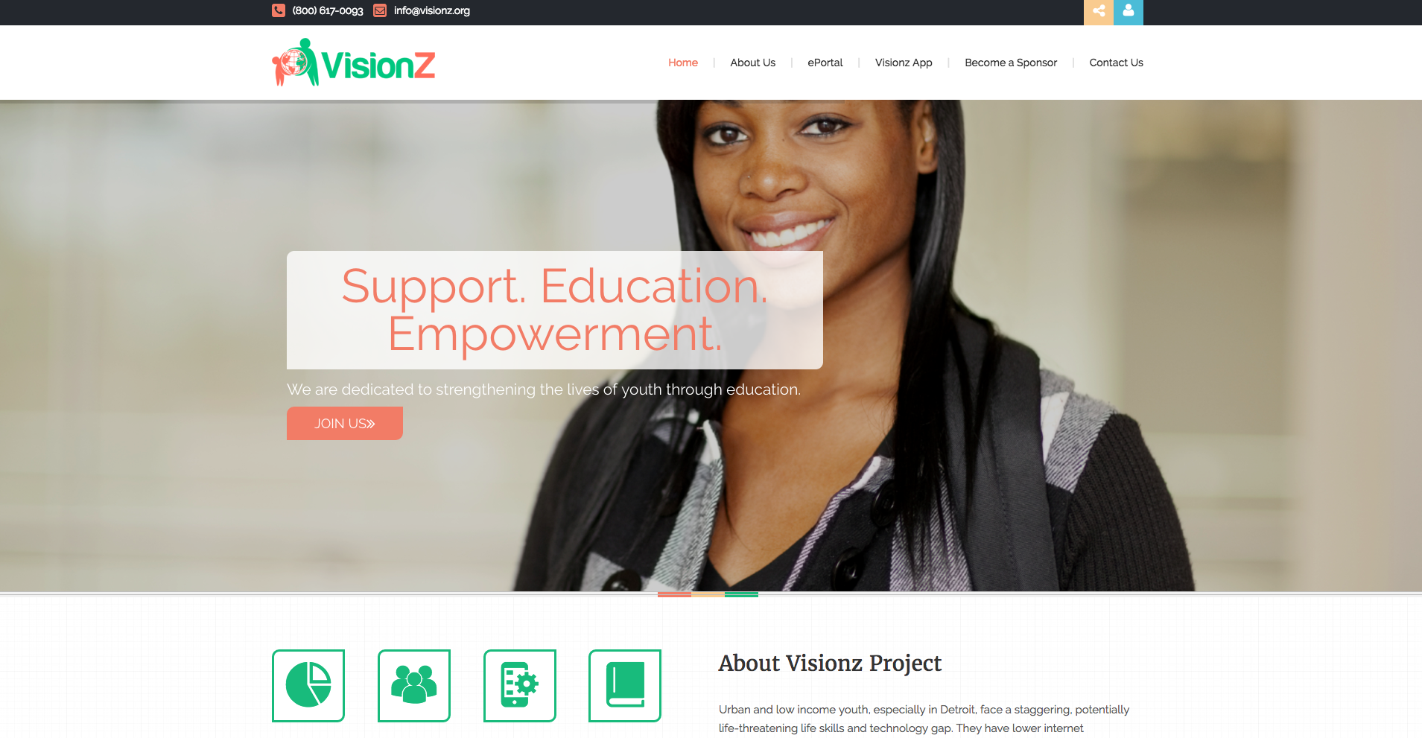
The Company will also utilize a series of digital marketing initiatives to drive website engagement and promotions through e-mail marketing, online advertising, and online resources and content. This is a powerful way to engage frequent and new visitors with value added related content that links to the Company’s platform, while building the opt-in mailing list for additional cross promotion and prospective user follow-up.

Search Engine Optimization
Visionz will implement an aggressive search engine optimization strategy, whereby the Company will optimize its content using keywords related to ‘education’, ‘life skills’ and ‘employment’. By creating website content, online blogs, and forums related to its target keywords, Visionz will organically aggregate higher on Google, Bing and Yahoo search engines when users search for these specific keywords.

Pay Per Click Campaign
The Company will also utilize search engine marketing campaigns to target potential users. This will include pay-per-click ad campaigns that target high search volume terms relevant to the business in order to drive traffic to the website. Visionz will analyze and opt for keywords that are the most cost effective in terms of driving traffic to the website.

Online Banner Advertising
The Company will identify the best related websites to purchase banner and display ad space. The ads will be visually engaging and include a direct link to Visionz thus providing the traffic and brand awareness needed for increasing market share. The Company will work with its marketing partners to increase online presence through their websites, blogs, forums, and social media channels further driving traffic and brand recognition.

Social Media & Online Blog
A solid online social media presence represents an inexpensive promotional and informational marketing strategy. Additionally, a strong online social media will be crucial for the Company’s success due to the nature of its format.
Figure 18: Visionz Twitter Page
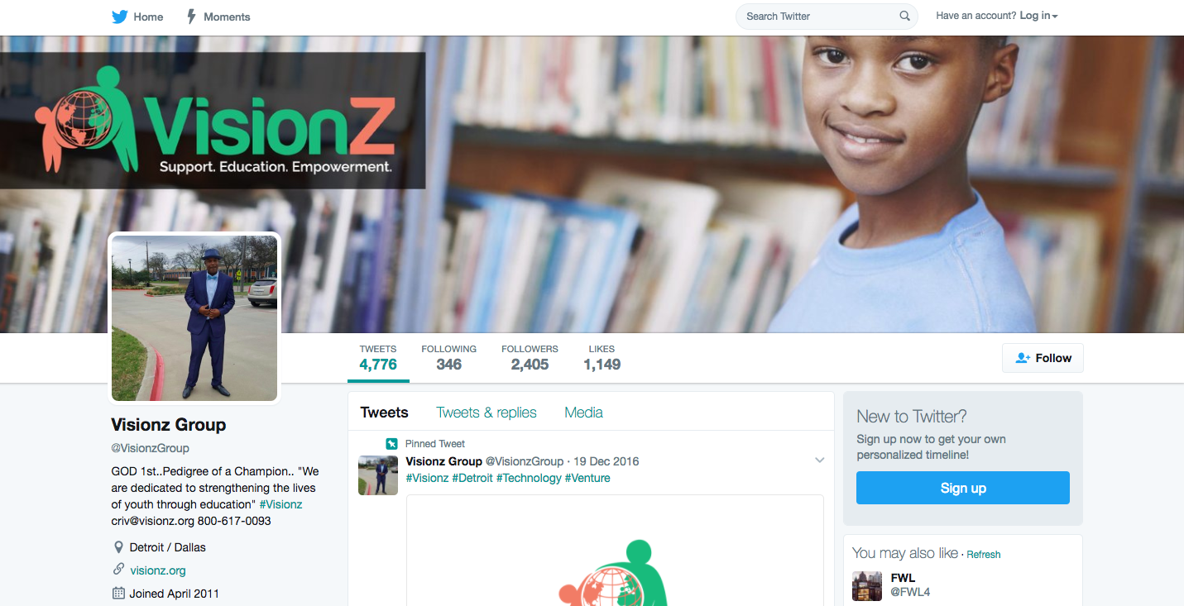
Visionz currently operates various social media platforms, including Facebook, Twitter, Instagram, and Online Blogs. Social media posts and online blog forums, while less official, are a great venue for more creative presentations of the Visionz brand. Real-time updates on these sites will keep customers in the loop regarding offerings, special promotions, and sponsorship activity. The social media channels will also allow followers and subscribers to receive special benefits, such as discounts or invitations to special events, encouraging an “insider” feel with loyal users.

Direct Marketing Channels

Direct Sales Team
Visionz will employ a skilled direct sales team that focuses entirely on promoting and creating accounts for non-profit organizations and secondary school programs who seek to use the portal as a supplemental technology for their existing educational and life skills training programs. The Company will allocate resources to its sales team to present the Company’s value proposition to institutions seeking to utilize the platform and potential sponsors who may potentially purchase premium advertising packages. The sales team will focus on creating target lists of potential schools, non-profit organizations that share similar missions and will develop relationships with the essential decision makers within these organizations to present the Visionz app and value proposition.
The Company will arrange conference calls and webinar presentations with distant prospects when geography is a limiting factor. The benefits of a direct sales approach include lower upfront marketing costs, enhanced lead generation, and immediate results.

Special Events
The Company will engage with prospective school programs and non-profit organizations, as well as students and their parents at special events throughout the year. Active participation at these events will allow Visionz to educate schools, teachers, and parents about the Company’s platform and value. The Company will also use this interaction to also learn about the needs, wants, and expectations of all types of users.
Special events can include local and regional expos, literary conferences, community events, festivals, and season openers. This will be an effective method of offline marketing to increase brand awareness and make the general public aware of the many features and functions available via Visionz. The Company will also aim to host such events and create an opportunity to promote the platform’s value as well as promote its overall mission and vision. For example, the Company will introduce a special event through a mobile education trailer. The purpose of the event will be to assist users in building their profiles and educating parents on utilizing the profile effectively, in addition to providing best practices for implementing the app for optimal gamification.

Networking
As with any relationship-based business, the Company will benefit from participating in a number of networking opportunities that have the potential to yield new business contacts as well as nourish existing ones. Visionz representatives will attend a variety of events that draw substantial numbers of educational leaders, political leaders, and recruitment leaders.
Active participation at these events will allow the Company to educate teachers, students, and recruiters about the Company’s technology and value. The Company will also use this interaction to also learn about the needs, wants, and expectations of all types of users. This will be an effective method of offline marketing to increase brand awareness and make the general public aware of the many features and functions available via Visionz. The Company will also aim to host such events and create an opportunity to promote the platform’s value as well as promote its overall mission and vision.

Word of Mouth & Referrals
Visionz plans to utilize word of mouth marketing and referrals in order to build trust and reliability amongst users across the United States. Happy users are drawn to discuss their experience with friends, family, and colleagues, resulting in new user acquisition for the Company. Positive customer testimonials and reviews are the strongest forms of marketing. This is important in creating a valuable experience and brand for users. This tactic allows prospective users to have more confidence and trust in the Company’s offerings when exploring their options for joining Visionz.

Media Campaign

Print Media & Publications
The Company will place ads in educational and recruitment-related magazines across the country. The Company will also purchase ad space in U.S. newspapers. These advertisements will include the Company’s web address, as well as photos or comments from the Company’s spokespersons.

Public Relations
Visionz will focus on securing editorial coverage with various media outlets targeting the desired market. The team will reach out to relevant school districts, high-traffic websites, and blogs in order to create a “buzz” about the Company’s features and overall value. The PR firm’s main responsibility consists of ongoing media outreach with top tier media sources in the industry as well as prominent online sites and bloggers. Public Relations efforts will also include quarterly creative programming ideas and pitches that will keep the Company in the media spotlight and provide the media with an ever-changing story angle, increasing the Company’s opportunity for consistent media coverage.

Influencers
Visionz will partner with influential athletes and entertainers that are known for advocating educational and life skills preparation for at-risk youth. These influencers will be able to promote and champion the use of the Visionz e-Portal both to their online followers and in the community.

Operations Plan

Corporate Information
Corporate Entity Name | Visionz Group, LLC
Address | 847 Sumpter Road, Suite #402, Belleville, MI 48111
Business Name | Visionz
State of Registration | Michigan
Founders | Chris Rivers & Willie Rivers
Date Founded | 2016

Corporate Structure
Visionz Group, LLC is registered as a Limited Liability Company in the State of Michigan under the leadership of Founder and President, Chris Rivers. The breakdown of the Company’s current organizational structure can be seen in the figure below.
Figure 19: Visionz LLC – Projected Operational Structure

Management Team

Chris Rivers – President & Marketing Guru
Chris Rivers grew up in the shadow of his father Willie's legendary career at Ford Credit, but that hasn't stopped him from carving his own legacy as an educator and successful businessperson with substantial experience in sales, marketing and business startups.
For more than 15 years, Chris has worked with established companies, startups and offshore environments to help then maximize revenue, develop distribution strategies, and deliver unparalleled customer service. When he worked at Time Warner alone, he launched five major, national sales campaigns, raising the bar for sales performance for hundreds of employees.
Despite his success at Fortune 500 companies, it was his passion for helping young people that drove his development of the Visionz Project.
In 2011, during a visit to his hometown of Detroit, Chris connected with a former high school classmate who, despite being a highly regarded athlete with good grades and a bright future, fell into a repetitive cycle of petty crime and unemployment. At 40, his friend could not find a way to escape that cycle. Feeling a sense of helplessness, Chris created the Visionz Project to help at-risk youth escape the same fate.
Since 2001, Chris has mentored at-risk youth, partnering with the Boys and Girls Club and providing engaging and interactive educational training. In the mid 2000s, Chris created a Seattle Partnership to give away free, refurbished desktop computers to at-risk youth who completed an educational program. He has also helped vulnerable North Texas youth develop their musical talents, providing encouragement and financial support when necessary.
With the Visionz Project, Chris will help at-risk teens learn the skills to earn money, save it, and invest in their futures. His past experience as an educator and mentor will prove invaluable to the project

Willie Rivers – Chairman of the Board
For dozens of years, Willie Rivers has played a key role in the community, helping people from all socio-economic backgrounds succeed through mentoring, leadership and financial literacy and job training. After earning a B.A. in Economics from Grambling State University, Willie's business legacy began at one of America's largest car companies.
More than 30 years ago, Rivers was hired at Ford Credit. His focus? Financial services. Over the years, he held a succession of senior positions, managing a budget of more than $300 million and a staff of almost 500 people. Willie's role was to help dealerships with their sales and marketing strategies, but his passion for the "people" side of business influenced his career decision to become actively involved in how Ford recruited, hired and developed its staff. He crafted recruiting strategies for minority conferences and events that helped Ford Credit increase diversity and inclusion at all levels. Chairing the Personnel Development Committee, Willie created career development plans for 175 management-level employees, mentoring them so they could thrive and succeed at Ford Credit.
In 2003, Willie founded the R&R Group, a consulting firm for both corporations and consumers. Corporate consulting focuses on diversity/ inclusion and customer satisfaction training. Willie uses workshops and seminars to help people master financial literacy, credit and money management.
Now retired from Ford, Willie is pouring his mentoring and educational passion into the Visionz Project, where he hopes to help Detroit teens succeed, professionally and financially.

Shawn Armour – Vice President and Solutions Architect
Shawn brings 30 years of professional experience and success in delivering high-level analysis, researching & identifying trends, and real-world problem solving skills. He brings experience from the private sector working for companies like Microsoft, Coca-Cola, Blue Cross & Blue Shield and from the public sector having worked for the City of St. Louis & the City of Seattle. In addition, he brings a unique skill-set that combines the ability to relate to youth and young adults and exceptional business execution skills. His knowledge of various business best practices allows him to transition quickly and facilitate to get the job done. Shawn is an undergraduate of Grambling State University where he obtained a Bachelor’s degree in Accounting and an Associate’s degree in Computer Science. He also holds a Master’s in Business Administration with a concentration in Finance from Webster University and is a PH.D. Candidate in Education Technology from Walden University. Shawn enjoys being an advocate for our youth facilitating a non-profit called Compukidz, who’s focus is on the “T” S.T.E.A.M, he is teaching in the Federal Way School system and is a youth football coach for the Benson Bruins youth football program.

Hiring Strategy
Visionz will need to hire additional support team members to assist in the expansion of the business, including a sales team to serve in a business development capacity to onboard new licensing customers and strategic partners. The following figure shows the detailed key hiring needs schedule based on level of priority and time to hiring. This will ensure that the Company has the appropriate team members serving crucial functions of the business for efficient and effective operations as the Company begins to expand and ramp-up the business.
Job Title | (Y1) | (Y2) | (Y3) | (Y4) | (Y5)
Chris Rivers (President) | 1 | 1 | 1 | 1 | 1
Willie Rivers (Chairman of the Board) | 1 | 1 | 1 | 1 | 1
Shawn Armour (Vice President & Solutions Architect) | 1 | 1 | 1 | 1 | 1
Preston Howell (Chief Strategist) | 1 | 1 | 1 | 1 | 1
IT Support Coordinator | 0 | 0 | 1 | 1 | 1
Tech Engineers | 1 | 1 | 1 | 1 | 1
Sales / Biz Dev Team | 2 | 2 | 5 | 5 | 5
Account Managers | 0 | 1 | 3 | 3 | 3
Marketing Associates | 0 | 1 | 1 | 1 | 1
Administrative Assistant | 0 | 0 | 1 | 1 | 1
TOTAL | 7 | 9 | 16 | 16 | 16

Key Operational Milestones
Visionz has identified the immediate milestones and goals that the Company would like to accomplish prior to the full launch of the business. The following figure shows each of these operational milestones, as well as their deployment schedule.
Milestone | Deployment
- Complete Strategic Business Plan | - Q2 2017
- Develop Business Model & Financial Assumptions | - Q2 2017
- Complete Technology App Wireframe / Features / Functionality | - Q2 2017
- Begin Tech Development of Mobile App and Web App | - Q2 2017
- Create Tactical Sales & Marketing Plan by Region | - Q2 2017
- Business Development Efforts to School Districts & Programs | - Q2 2017
- Secure Interest and Letters of Intent for Platform Utilization | - Q2 2017
- Secure Capital | - Q3 2017
- Launch Beta of Web and Mobile App | - Q4 2017
- Implement Sales & Marketing Initiatives | - Q4 2017
- Full Market Launch | - Q1 2018
- Tracking Benchmark Utilization and Key Performance Indicators | - Ongoing
- Continue Implementation of Hiring and Marketing Schedules | - Ongoing

Financial Plan
Below is a breakdown of the Company’s financial model.

Capital requirements
Visionz will require $721,209 in funding in order to jumpstart operations. Fund uses are listed below:
Figure 20: Visionz Fund Uses

Revenue Metrics
The Company has completed its financial projections based on several key assumptions. These assumptions are broken down below:

Traffic
The Company projects 4,668 average monthly visitors in Y1. Visionz assumes a 4% unique visitor to user stabilization ratio, equating to 597 total users by the end of Y1.
Figure 21: Visionz Traffic Assumptions
 | Total Monthly Unique Visitors | Cumulative Total Registered Users | Cumulative Total Youth Learners | Cumulative Total Adult Learners
Year 1 | 4,668 | 597 | 358 | 239
Year 2 | 73,126 | 7,161 | 4,296 | 2,864
Year 3 | 266,768 | 14,409 | 8,645 | 5,763
Year 4 | 469,090 | 23,069 | 13,841 | 9,228
Year 5 | 702,533 | 32,891 | 19,734 | 13,156
Further, the Company projects that 60% of the user base will be youth learners, while 40% will be adult learners, resulting in 358 youth learners and 239 adult learners by the end of Y1 respectively.

Account Breakdown
Throughout its operations, the Company expects 40% of users to have a free account, while 30% will have a first level training account, and 30% will have a second level training account.
Figure 22: Visionz Account Breakdown
 | Basic (Free) | First Level Training | Second Level Training
Year 1 | 40% | 30% | 30%
Year 2 | 40% | 30% | 30%
Year 3 | 40% | 30% | 30%
Year 4 | 40% | 30% | 30%
Year 5 | 40% | 30% | 30%

The Company projects the first level training account to cost $30 per month, while the second level training will cost $45 each month. This will result in an annual subscription revenue of $38,312 in Y1, increasing to $5,766,387 by Y5.
Figure 23: Visionz Account Pricing
 | First Level Training Monthly Cost | Second Level Training Monthly Cost | Annual Subscription Revenue
Year 1 | $30 | $45 | $38,312
Year 2 | $30 | $45 | $600,221
Year 3 | $30 | $45 | $2,189,631
Year 4 | $30 | $45 | $3,850,287
Year 5 | $30 | $45 | $5,766,387

SaaS Licensing
The Company expects 11 organizations to utilize the Visionz Software Licensing by the end of Y1. By the end of Y5, the Company expects a cumulative total of 44 organizations using the software.

Figure 24: SaaS Licensing Assumptions
 | Cumulative Total Organizations Using Visionz Software Licensing
Year 1 | 11
Year 2 | 20
Year 3 | 31
Year 4 | 39
Year 5 | 44

The Company expects that 25% of these organizations will have less than 2,000 users. Further, 50% of the organizations will have between 2,001 and 3,000 users, while 25% will have more than 3,001 users.
Figure 25: Organization Segmentation by Users
 | Tier 1 - Less than 2,000 Users | Tier 2 - 2,001 – 3,000 Users | Tier 3- More than 3,001 Users
Year 1 | 25% | 50% | 25%
Year 2 | 25% | 50% | 25%
Year 3 | 25% | 50% | 25%
Year 4 | 25% | 50% | 25%
Year 5 | 25% | 50% | 25%

The Company’s price points for each tier of organization can be found in the table below.
Figure 26: Organization Pricing
 | Tier 1 - Less than 2,000 Users | Tier 2 - 2,001 – 3,000 Users | Tier 3- More than 3,001 Users | Total Licensing Revenue
Year 1 | $1,167 | $2,000 | $2,500 | $163,946
Year 2 | $1,167 | $2,000 | $2,500 | $365,578
Year 3 | $1,167 | $2,000 | $2,500 | $593,676
Year 4 | $1,167 | $2,000 | $2,500 | $812,042
Year 5 | $1,167 | $2,000 | $2,500 | $964,296

Ancillary Services
The Company will sell its curriculum to new clients for a $250 fee per job post. This will result in $56,931 of revenue from total curriculum sales in Y1, increasing to $258,514 by Y5.
Figure 27: Curriculum Sales Revenue
 | Cumulative New Clients | % of New Clients Purchasing Curriculum | Average Number of Programs Purchased | Fee Per Job Post | Total Curriculum Sales Revenue
Year 1 | 23 | 60% | 2 | $250 | $56,931
Year 2 | 42 | 60% | 2 | $250 | $116,906
Year 3 | 60 | 60% | 2 | $250 | $183,627
Year 4 | 67 | 60% | 2 | $250 | $229,418
Year 5 | 76 | 60% | 2 | $250 | $258,514

The Company projects 15% of new clients will purchase consulting services for an average consulting fee of $3,500. This will result in $99,630 in Y1, increasing to $452,399 by Y5.
Figure 28: Consulting Sales Revenue
 | Cumulative New Clients | % of Clients Purchasing Consulting Service | Average Consulting Fee | Total Consulting Revenue
Year 1 | 23 | 15% | $3,500 | $99,630
Year 2 | 42 | 15% | $3,500 | $204,585
Year 3 | 60 | 15% | $3,500 | $321,347
Year 4 | 67 | 15% | $3,500 | $401,481
Year 5 | 76 | 15% | $3,500 | $452,399

The Company projects 25% of new clients will purchase focus group services for an average fee of $1,000. This will result in $47,443 in revenue from focus groups, increasing to $215,428 by Y5.

Figure 29: Focus Group Revenue
 | Cumulative New Clients | % of Clients Purchasing Focus Group Service | Average Focus Group Fee | Total Focus Group Revenue
Year 1 | 23 | 25% | $1,000 | $47,443
Year 2 | 42 | 25% | $1,000 | $97,422
Year 3 | 60 | 25% | $1,000 | $153,022
Year 4 | 67 | 25% | $1,000 | $191,182
Year 5 | 76 | 25% | $1,000 | $215,428

Operating Expenses
VIsionz expects total operating costs to increase from $249,731 in Y1 to $1,068,796 in Y5. A detailed breakdown of the Company’s operating expenses can be found below.
Figure 30: Visionz Operating Expenses
Operating Expenses |  | Year 1 | Year 2 | Year 3 | Year 4 | Year 5
Advertising, Marketing, & Promotion |  | $22,808 | $74,799 | $181,099 | $286,578 | $397,525
Automotive Expenses |  | $3,000 | $3,000 | $3,000 | $3,000 | $3,000
Bank Charges & Merchant Fees |  | $9,123 | $29,919 | $72,440 | $114,631 | $159,010
Basic Employee Costs |  | $12,600 | $16,200 | $28,800 | $28,800 | $28,800
Computer Expenses |  | $6,000 | $6,180 | $6,365 | $6,556 | $6,753
Dues & Subscriptions |  | $18,000 | $27,000 | $40,500 | $60,750 | $91,125
Insurance Expenses |  | $1,800 | $1,890 | $1,985 | $2,084 | $2,188
Meals & Entertainment |  | $6,000 | $9,000 | $13,500 | $20,250 | $30,375
Office Supplies |  | $4,200 | $6,300 | $9,450 | $14,175 | $21,263
Professional Fees (Legal, Accounting, Consulting) |  | $6,000 | $12,000 | $18,000 | $27,000 | $40,500
Rent Expenses |  | $58,800 | $75,600 | $134,400 | $134,400 | $134,400
Telephone / Internet Expense |  | $4,200 | $4,200 | $4,200 | $4,200 | $4,200
Travel Expense |  | $18,000 | $22,500 | $28,125 | $35,156 | $43,945
Utilities |  | $1,200 | $1,224 | $1,248 | $1,273 | $1,299
Website & Server Expenses |  | $60,000 | $63,000 | $66,150 | $69,458 | $72,930
Miscellaneous |  | $18,000 | $20,700 | $23,805 | $27,376 | $31,482
TOTAL |  | $249,731 | $373,512 | $633,067 | $835,687 | $1,068,796

Personnel Expenses
The Company expects total headcount cost to increase from $207,478 in Y1 to $886,986 by Y5. A full list of personnel expenses can be found below.
Figure 31: Visionz Salary Assumptions
Management Team | (Y1) | (Y2) | (Y3) | (Y4) | (Y5)
Chris Rivers (President) | $10,000 | $10,000 | $50,000 | $50,000 | $50,000
Willie Rivers (Chairman of the Board) | $10,000 | $10,000 | $50,000 | $50,000 | $50,000
Shawn Armour (Vice President & Solutions Architect) | $10,000 | $10,000 | $50,000 | $50,000 | $50,000
Preston Howell (Chief Strategist) | $10,000 | $10,000 | $50,000 | $50,000 | $50,000
Total Management Team Compensation | $40,000 | $40,000 | $200,000 | $200,000 | $200,000
Support Team
IT Support Coordinator | $65,000 | $66,950 | $68,959 | $71,027 | $73,158
Tech Engineers | $65,000 | $66,950 | $68,959 | $71,027 | $73,158
Sales / Biz Dev Team | $40,000 | $41,200 | $42,436 | $43,709 | $45,020
Account Managers | $40,000 | $41,200 | $42,436 | $43,709 | $45,020
Marketing Associates | $40,000 | $41,200 | $42,436 | $43,709 | $45,020
Administrative Assistant | $35,000 | $36,050 | $37,132 | $38,245 | $39,393
Total Support Team Compensation | $145,000 | $231,750 | $556,973 | $573,682 | $590,892
Total Headcount Compensation | $185,000 | $271,750 | $756,973 | $773,682 | $790,892
Payroll Taxes and Other Benefits | $22,478 | $33,018 | $91,972 | $94,002 | $96,093
Total Headcount Cost | $207,478 | $304,768 | $848,945 | $867,684 | $886,986

Income Statement
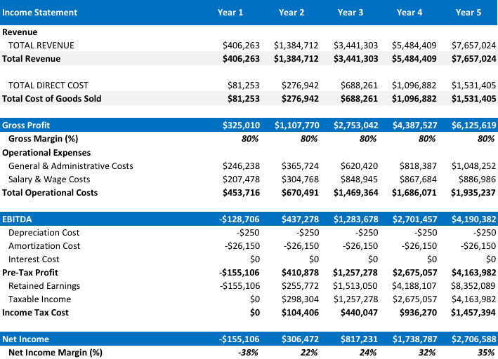

Balance Sheet
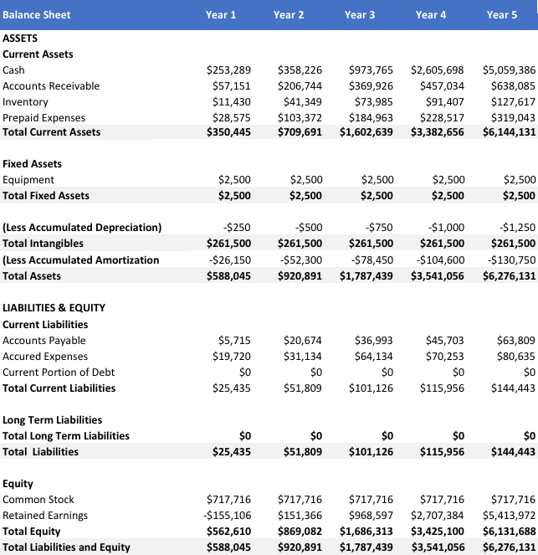

Cash Flow

appendix
GSU Life Skills and Professional Development Seminars
Social Etiquette and Business Protocol | All About Credit
The Social Etiquette and Business Protocol Seminar is designed to prepare individuals for the new and often demanding social and professional situations they will face as adults. Whether it is preparing for a graduate school interview, learning how to feel confident at social events, dining in a formal restaurant with their boss or clients or interviewing for a first time job, this seminar will provide students the real-world essential social skills that will give them the confidence to successfully handle these situations.  Seminar Topics:  - Essential Manners and Social Skills for University Students  - Business Etiquette and Blunders…And How Fix Them  - Professional Etiquette  Instruction and coaching will be provided to develop participant’s:  - Everyday Basic Etiquette  - Dining Skills and Table Manners  - Meeting and Greeting  - Dress, Grooming and Style  - Social Media Postings  - Appropriate Classroom Behavior  - Appropriate Student/ Instructor Interaction  (Estimated time – 2 Hours) | When it comes to making a major purchase or planning for your financial future, good credit is critical to your success. This seminar will provide instruction on how to establish and maintain credit, the basics of credit scoring and reporting, and how to avoid credit traps.  Discussion topics include:  - Your Credit and Why it is Important.  - Establishing and Maintaining Good Credit.  - Understanding Credit Scoring.  - Restoring Your Credit  - Avoiding Credit Trap
How to Keep the Job Now That You Are Hired | Money Management
Believe it or not, your preparation doesn't end once you've found a job. Truly making it in a career or job field means continually growing. This seminar will provide students with the work traits and strategies to create advancement opportunities and job security.  Seminar Topics:  - Map your success  - Establishing and maintaining good work habits  - Taking initiative  - Know your company's values, norms, and culture  - Know your company’s social media policy  - Performance evaluation  - Dress codes  - Work place Do's and Don'ts  Students will receive instruction and coaching to give them the essential skills to thrive in their job by showing acumen in:  - Goal setting  - Distinguishing themselves from their co-workers  - Knowing their performance expectations  - Professional business office decorum and professionalism  - Social media behavior  - Electronic business arena communications; dressing appropriately for your profession; and much more.  (Time – 2 Hours)  Networking Skills | From the importance of good credit to budgeting and goal setting, this workshop offers solid information and hands-on activities to build money management skills. Participants will gain new insight into their spending and saving habits, learn how to avoid pitfalls, and develop strategies for financial success.  - The seminar include lessons on:  - Your Credit and Why it is Important  - Managing Your Money  - Developing A Spending Plan  - Budgeting  - Financial Goal Setting  - Planning for Your Future  - Avoiding Credit Traps  (Time – 2 Hours)  Communication Skills
Networking is a planned, and ongoing effort. The Networking Skills Seminar is designed to help students develop the skills to set career goals,  develop strategies for achieving them, take action, evaluate how well their plan is working, and make changes as necessary. Their first job will not be their last job—therefore they will learn to use networking as a long term process.  Seminar Topics:  - Start Networking While In College  - Network Your Way To a Job  - Getting The Most Out Of a Job Fair  Instruction and coaching will be provided to help participants:  - Understand Why Networking Is Important  - Identify Ways of Describing Themselves And Their Career Goals Succinctly  - Recognize and take advantage of a networking opportunity when it arises  - Develop Networking Skills  - Increase Awareness of Networking Resources  (Time – 2 Hours) | All of us are constantly in a state of giving and receiving communications. Problems arise when one does not receive, or understand, the message sent in the communication as it was intended, or when one subconsciously sends a nonverbal message that contradicts the spoken word. This seminar will help students understand the importance of good communications skills at school and at work.  Upon completion of this seminar students will understand the importance of good communication skills in the classroom and workplace. Participants will be provided instruction and coaching to achieve the following objectives:  - Understand the importance of good communication skills  - Understand how nonverbal communication skills affect their overall communications in the classroom and at work  - Use effective listening techniques  - Use proper oral communication skills  - Proper telephone etiquette  (Time – 2 Hours)
Interviewing Skills
A highly interactive and practice driven seminar to provide students with the tools to be successful in their job search. The interview instruction and coaching, which includes behavioral interviewing, will prepare students to effectively tell their story and how they can fit with and contribute to an organization.
Seminar Topics
- Preparing For the Interview
- Ten Rules of Interviewing
- Dressing for the Interview
- The Behavioral Interview
- Turning the Tables in the Interview
- Questions Asked By Employers
- Questions to Ask Employers
- The Informational Interview
- Appropriate pre-employment inquiries
- Your 60 second commercial – “The elevator speech”

Students will receive instruction and coaching to enhance their ability to:
- Research the company with whom they are interviewing
- Clean-up their Digital footprint to enhance and protect their online reputation
- Overcome the competition
- Dress appropriately for interviews, job fairs and business
- Demonstrate professional behavior
- Communication effectively
(Estimated Time 2 hours)

U.S. Department of Education

